**Week 3: Using GPS and projections**

**IMPORTANT: For this exercise, you will need a smartphone (Android or iPhone) with localisation capabilities. If you do not have access to such device, please contact Hannah White to arrange an alternative exercise.**

**During this practical exercise, you will collect data that you will use to create a practice map to submit in week 8 (010, 10th of November 2021 at 2pm on Canvas).**

**Overview**

During this practical exercise, you will learn how to install various plugins into QGIS, how to add a basemap on a project, how to use a smartphone to capture some locations (waypoints) and add information. You will then practice using the symbology to create various thematic maps. Finally, you will learn how to calculate distances between points in QGIS.

**A. Design the task**

For this exercise and the practice map you will submit in week 8, you will collect some location data (Geography) using the GPS from a smartphone. For each location, you will also collect some Information. You are required to collect two variables: one nominal (text variable) and one scale (numeric variable).

For example, you can survey the trees in your area. You will record the location for each tree, the species of tree (the nominal variable) and an indication of the size of the tree with a size index from 1 to 5 for example (the scale variable). Another example could be a duck survey along a river. You could record the species of duck (the nominal variable) and the number of individuals at each location (the scale variable). You can also record non-biological features as long as you have your two variables for each location.

**B. Prepare a QGIS project**

1. Open QGIS with a blank project.
2. One of the powerful advantages of QGIS is that there is a large community of users and some of them are contributing to the software by creating a sharing plugins. To synchronise the data you will be collecting with your phone and your QGIS project, you will need a plugin called Mergin. In the Plugins menu, select Manage and Install plugins… In the search box, search for “Mergin”. Select it in the list and click on the Install Plugin button. Once the plugin is installed, you will have to restart QGIS.
3. To add some context to your project, you are going to download a basemap. This will be a raster layer representing some contextual data that will be downloaded from various sources as you zoom in and out and change the location of the map view. For that, you are going to install another plugin called QuickMapServices. Use the same procedure as before to install that plugin. Once installed, you should have a QuickMapServices entry in the Web menu. Open that menu and go to OSM and select OSM Standard. What kind of new layer do you have in your project? Where is the raw data stored? Try to zoom in your local area, what is happening?

You can also try to add a Google Satellite image basemap. In the QuickMapServices menu, select Search QMS. In the Search QMS panel, search for Google Satellite image and click on the Add button next to the result. Look at this new layer. You can choose which one you want to use as the background for your data collection. You can also explore different basemap from QMS. Once ready, you can close the Search QMS panel.

1. You can now create an empty point vector layer that will be populated with the data you will be collected in the field. Click on the New Shapefile Layer button (). In the New Shapefile Layer window, under File name, click on the 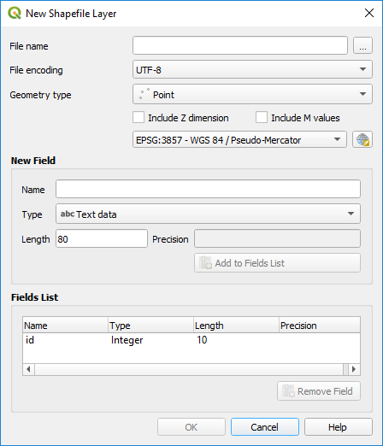 button and browse to a convenient location and, with the New folder button, create a new folder that represent your data (e.g. TreeSurvey) and within that folder, enter a filename that represents your data collection (e.g. TreePoints.shp). Under Geometry type, make sure Point is selected.

In the CRS menu (you should have EPSG: 4326 – WGS 84), click on the CRS selector button (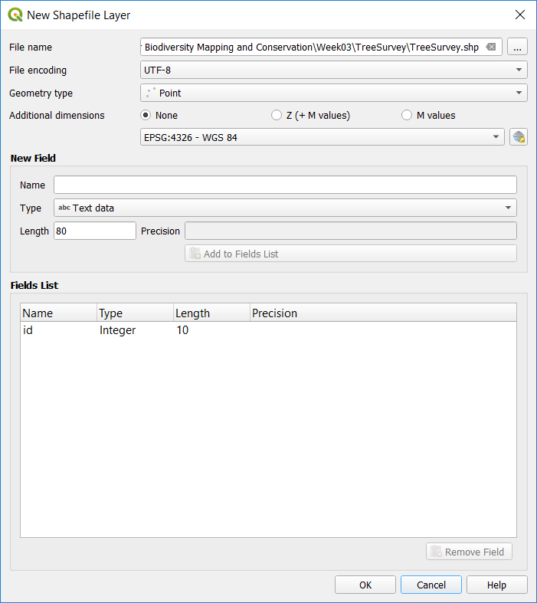) and in the Filter box, type “British National Grid”, you should have “OSGB 1936 / British National Grid EPSG: 27700” in the Predefined Coordinate Reference Systems list. Click on it, check the coverage of the CRS (the UK) and click on OK.

Create a new field for your nominal variable. Enter a Name and set the Type as Text data (e.g. Species); click on the Add to Fields List button. Enter another name for your scale variable (e.g. Size) and this time, set the Type to either Whole number or Decimal number depending on the data you will be collecting (if you are unsure, put Decimal number) and click on the Add the Fields List. You should now have three fields in the Fields List: an id of type Integer and the two fields corresponding to the two variables you will be collecting. Click on the OK button (if you have a message windows about Transformations, just click on OK).

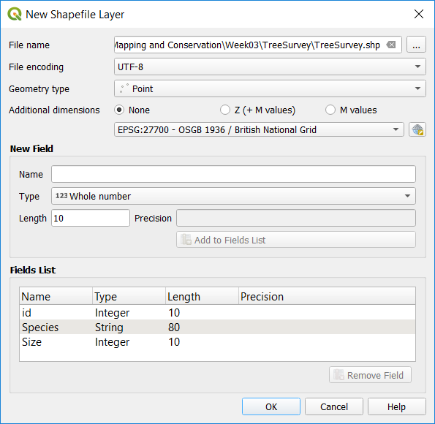

1. Save your QGIS project in the same folder where you saved the point shapefile.

**C. Upload your project to Mergin**

1. To upload your project to your phone, you will need a Mergin account. In your Browser panel, you should have a Mergin entry (if the Browser panel is not visible, go to View > Panels and tick Browser Panel). Right-click on the Mergin entry and select Configure. On the login window, click on the Sign up now link to create a Mergin account. Once created, you can go back to QGIS and login using the credentials you just set.
2. Right-click on the My projects entry within Mergin and select Create new project. Click on Package current QGIS project (i.e. it will use the QGIS project you’ve just created), keep the selected layers for the new project and click Next. Enter a meaningful name for the Mergin project.

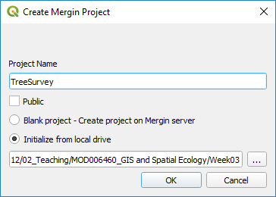

**D. Collect the data with your phone**

1. On your smartphone go to the Google Play or App Store to install Input from Lutra Consulting. Once the app is installed on your phone, you can run it. You will have to sign in to your Mergin account. Under My projects, you should see the project you just created. Click on the download button (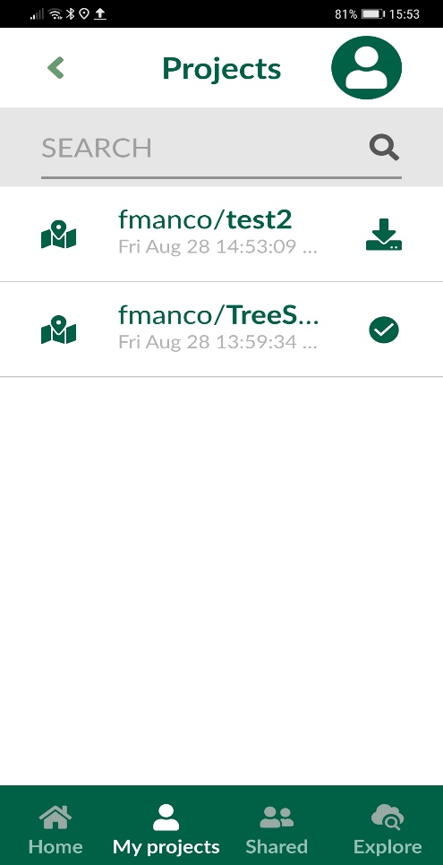) to add it into your phone.
2. Go to the Home screen and click on the project to open it. You can go to your location by clicking on the GPS button. To record a location, press the Record button. You can move the target to the exact location you want to record. Once happy, press the Add point button and then fill the fields with the Information. Click on Save when done.

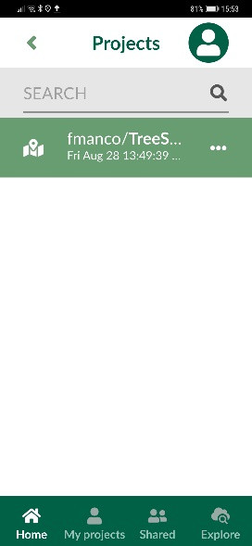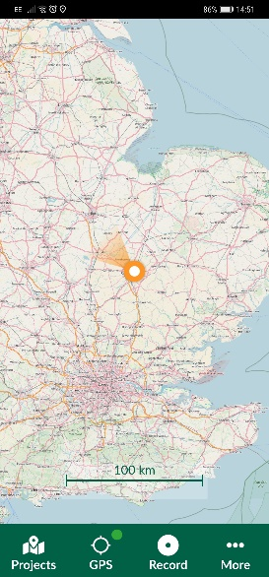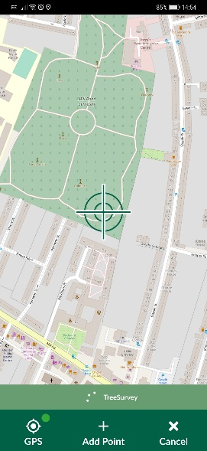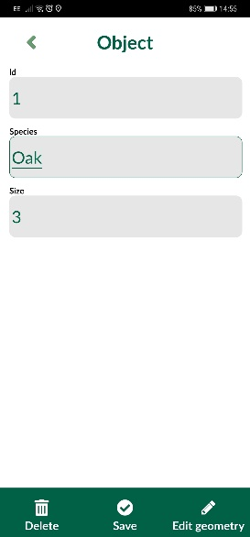

You can add more points until you have 15-20 locations with the associated data. Once finished, go to Projects, then to My projects and click on the synchronize button (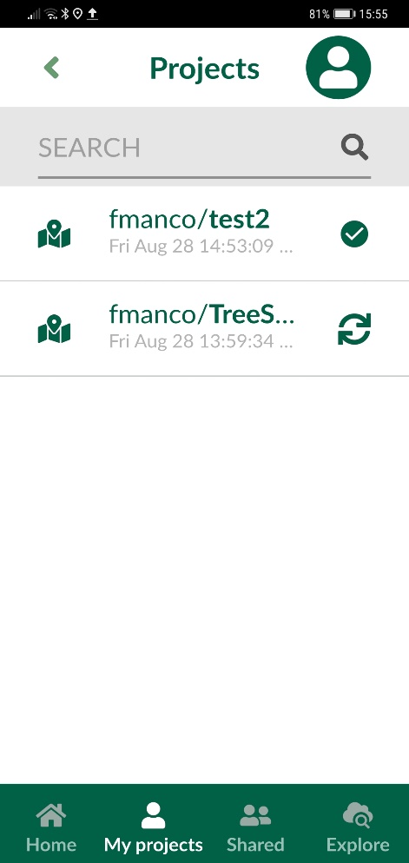).

**E. Synchronize your QGIS project.**

Back at your desk, in QGIS under Mergin > My projects, right-click on your project and select Synchronize. Your map and the content of your point layer should now be updated with the data you collected in the field. You can check the Geography (on the map view) and the Information (in the attribute table of the layer).

**F. Change the symbology**

Finally, you are now going to create some thematic maps from your data.

1. Open the point layer’s properties and go to the Symbology tab.
2. For the nominal variable (text), change the Symbology to Categorized. In the column selector, select the column from the attribute table that contains the nominal variable and click on the Classify button. You can double-click on each symbol to change its colour, symbol, size, etc…

Note: if the symbology does not work, you might have to remove the point layer (right-click, Remove) and add it again from your shapefile.

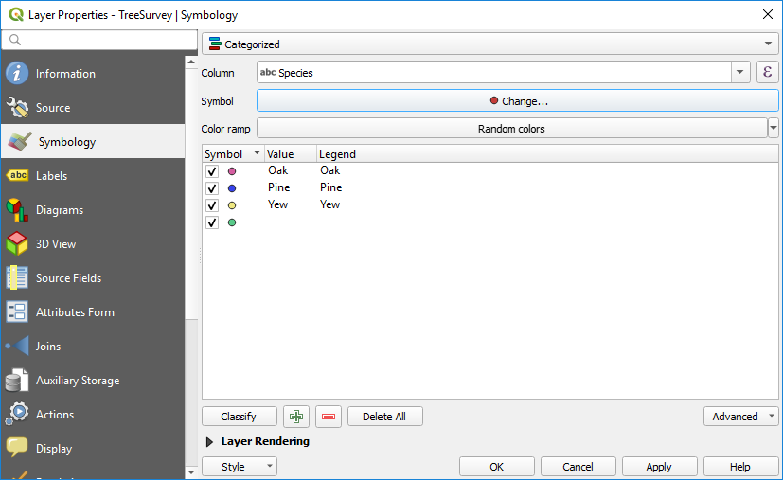

1. For the scale variable, change the Symbology to Graduated. In the column selector, select the column from the attribute table that contains the numerical data, change the Method to Size and click on Classify.

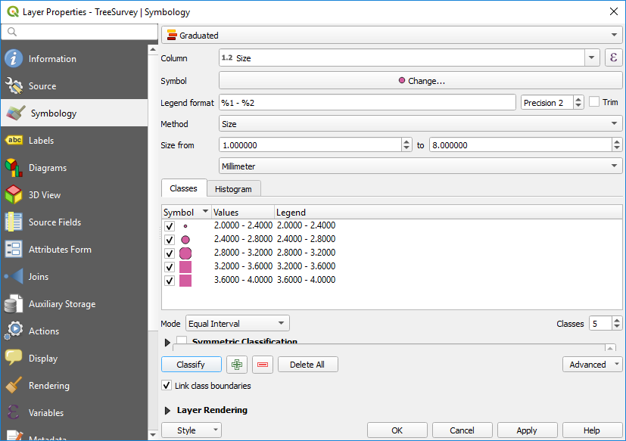

1. Now, you can create a more complex symbology using both the nominal (text) and scale variables. In the symbology, create a Categorized symbology as in step 2 above. Click on the symbol selector button (where there is the symbol currently being used) and next to Size, click on the 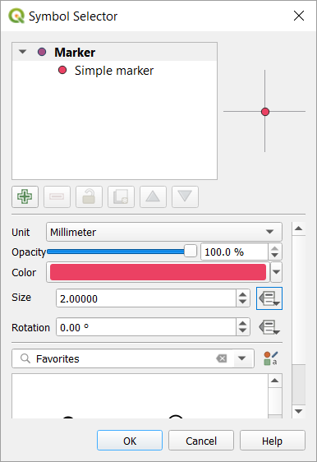 button. Select Field type and then the column containing the numerical information. Click on OK and OK.

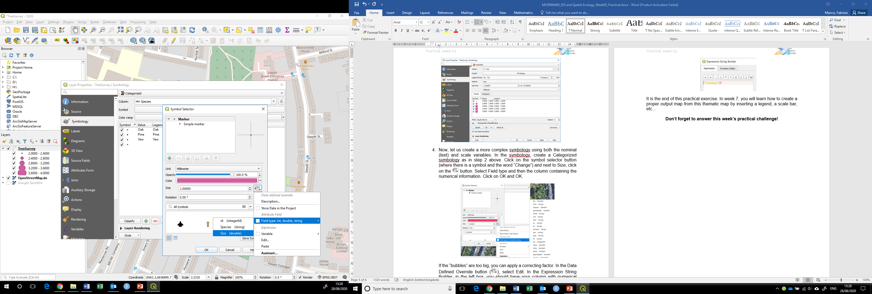

If the “bubbles” are too big, you can apply a correcting factor. In the Data Defined Override button (), select Edit. In the Expression String Builder, in the left box, you should have your column with numerical values. Insert the divide character (/) and then a number (you might have to try different values).

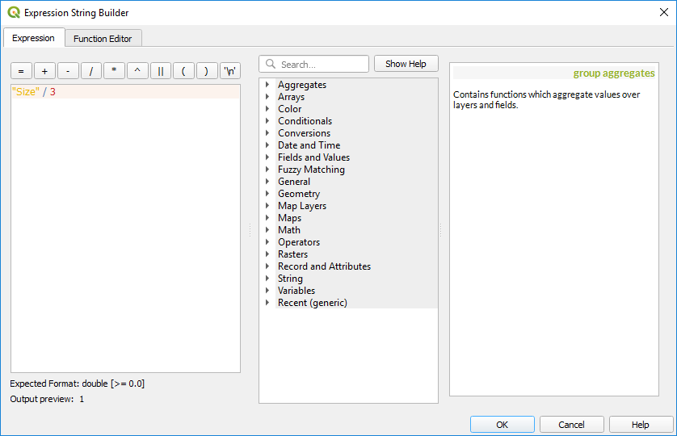

**G. Calculate the distances between points**

1. Finally, you are going to use the Distance Matrix tool to calculate the distances between each pair of points. In the Vector > Data Analysis select the Distance Matrix tool. Select your point layer as both the Input point layer and Target point layer. The unique ID field for both the Input and Target layers should be the “name” field. In the Ouput matrix type, select the Linear type. Change Use the nearest (k) target points to the number of points you have. In the Distance matrix, click on 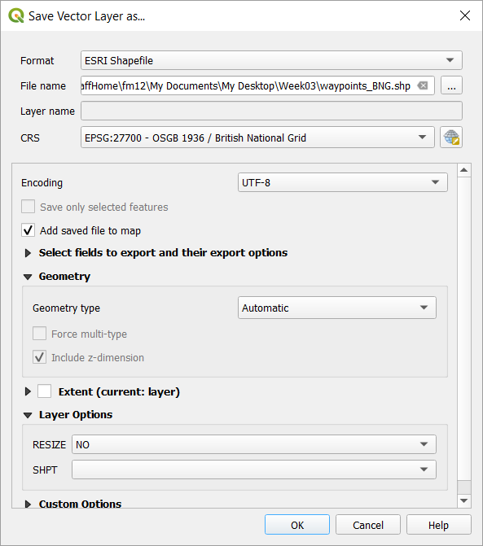 and select Save to File to browse to your folder and save the results as a csv file that you could then open in Excel for further analysis.

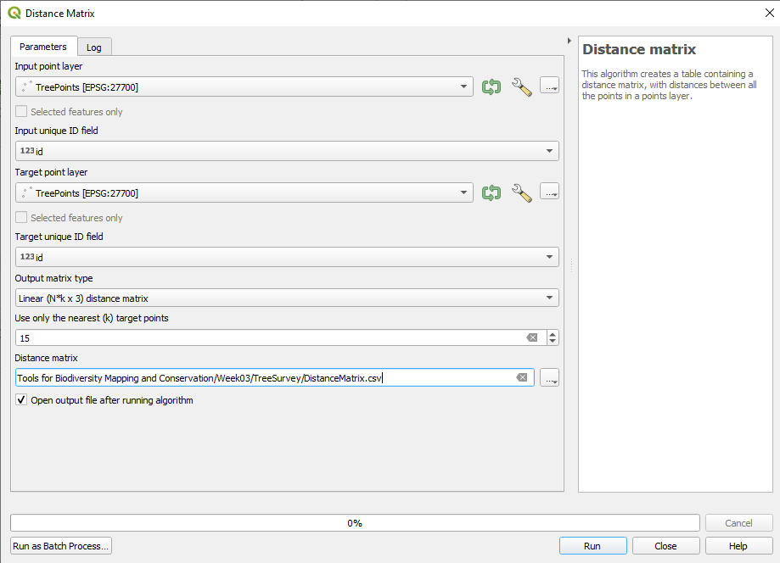

You should now have a Distance matrix “layer” in the list of Layers. Explore its attribute table to check your results. You can run the tool again and try different types of matrices (Standard or Summary). You can also force the calculation on only a set of closest points by setting the Use only the nearest (k) target points parameter.